**CH 245: ORGANIC CHEMISTRY 1 LABORATORY (Fall 2019)**

**Title:**

1. **Purpose: (1 point)**

The purpose of this lab is to be able to separate two immiscible aqueous compounds from each other, in this case, benzoic acid and dimethyl terephthalate, using various methods and equipment such as a separatory funnel, vacuum filtration, and distillation.

1. **Drawing of structure of the main compound or balanced chemical equation if synthesis is performed: (1 point)**

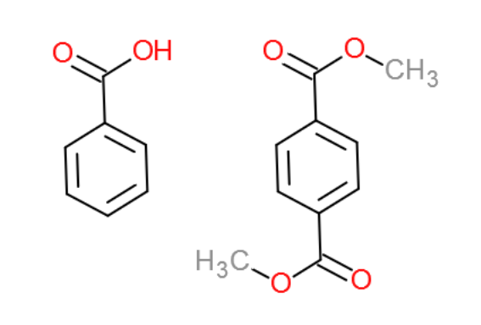

benzoic acid dimethyl

terephthalate

$$PhCOOH_{aq}+K_{aq}^{+}+OH_{aq}^{-}→PhCOO_{aq}^{-}+K_{aq}^{+}+H_{2}O_{l}$$

**3. Reagents and the major product (up to 6 points)**

|  |  |  |  |  |  |  |
| --- | --- | --- | --- | --- | --- | --- |
| **Name** | **M.W.**  (0.5 pts) | **Density**  (0.5 pts) | **Amount (grams/mL)**  (0.5 pts) | **Moles**  (0.5 pts) | **Hazards/Precautions**  **(MSDS data) and melting point or boiling point** (2 pts) | **Waste Disposal**  **(aqueous or organic)** (2 pts) |
| Benzoic acid | 122.12 | 1.27 g/cm3 | 3g | 0.025 | Skin irritation, eye damage | Organic |
| Dimethyl terephthalate | 194.19 | 1.2 g/cm3 | 2g | 0.010 | May cause skin, eye irritation | Organic |
| Potassium hydroxide | 56.11 | 2.12 g/cm3 | 40 mL 1.5M sol. | 0.060 | Corrosive, skin and eye damage, toxic if ingested | Aqueous |
| Hydrochloric Acid | 36.46 | 1.18 g/mL | 10 mL |  | Skin burns and eye damage, respiratory irritation | Aqueous |
| Dichloromethane | 84.93 | 1.326 g/cm3 | 25 mL | 0.390 | Skin, serious eye irritation, respiratory irritation | Organic |
| Magnesium Sulfate | 120.37 | 2.65 g/cm3 | 0.4g | 0.0033 | No information | Aqueous |

**4. Procedure (up to 2 points)**

|  |  |
| --- | --- |
| **Procedure** | **Observations and Lab Data** |
| A summary of the procedure done with bullet points) | Color changes, exothermic or endothermic reactions, gas generation, etc.; tare weights for flasks, etc. |
| * Obtain a 25 mL solution containing 3g benzoic acid and 2g dimethyl terephthalate dissolved in dichloromethane. * Obtain 40 mL of aqueous 1.5M KOH solution. * Place 25 mL DCM solution in separatory funnel and extract twice with 20 mL each of KOH solution and once with 20 mL distilled water. * Combine the aqueous layers in 100mL beaker and label as solution A. * Place DCM layer in 125 mL Erlenmeyer flask and add 0.4 g anhydrous magnesium sulfate. * Label this solution D and set aside. * Cool solution A in an ice bath. * Obtain 10 mL concentrated HCl in a beaker * Add dropwise HCl to solution A while stirring with a glass rod. * Test acidity of solution with pH paper. pH paper should turn red. * Filter the mixture with Buchner funnel and wash with a small amount of cold water. * Collect precipitated benzoic acid and allow to dry for a week. (beaker with parafilm and holes) * Filter solution D with gravity filtration into tared 50mL or 100mL round bottom flask. Add two boiling stones. * Set-up and distill solution D, discarding distilled DCM. * Leave dimethyl terephthalate flask to dry for week (parafilm with holes) |  |

**5.** Results; include actual yield in grams and % yield.

**Results (need to get signed by instructor or TA):**

1.64 g dimethyl terephthalate recovered

$$\frac{1.64}{2}*100=82\% recovery$$

4.45 g benzoic acid recovered

$$\frac{4.45}{3}*100=148\% recovery$$

|  |  |  |
| --- | --- | --- |
|  | **Benzoic Acid** | **Dimethyl Terephthalate** |
| **Mass Recovered** | 4.45 grams | 1.64 grams |
| **Percent Recovery** | 148% recovered | 82% recovered |
| **Measured Melting Point** | 122-123°C | 144-147°C |

**Conclusion:**

I **accomplished** a separation of two compounds, benzoic acid and dimethyl terephthalate, that were dissolved in the same solution. To do this, I **learned** how to separate an aqueous and organic solution in a separatory funnel, and practiced past techniques learned to eventually isolate the two compounds. An **issue** I had during the experiment was that the dropwise addition of HCl caused a large cloud-like mass of benzoic acid to form in my beaker, which was difficult to dry completely before putting away for storage. Thus, this could have left impurities that inflated the measured mass of the benzoic acid. **In the future**, I will add the HCl more rapidly into the solution and stir less in order for the benzoic acid to precipitate with less volume. The practical application of this lab is to show how multiple lab techniques chained together can isolate two very closely associated compounds from each other.

Post Lab Questions

Tetrahydrofuran – upper layer

Dichloromethane – lower layer

Ethyl Acetate – upper layer

Due to benzylamine’s presence of the nitrogen-hydrogen bond, we expect this chemical to be much more soluble in water than dichloromethane. The associated flowchart is attached to the picture of the lab data.

